ALGORITHM
1. Start program
2. Open file xml file
3. Parse XML into tree structure
4. Get root element
5. Create empty list called "data"
6. Find ALL specific tag tags in XML
7. For each defined tag found:
a. Get text inside tag
b. Remove extra spaces (strip)
c. Add cleaned text to "data" list
8. Convert list to set (removes duplicates automatically)
9. Sort set alphabetically (A → Z)
10. For each issue in sorted list:
Print issue name on new line
11. End program

DFD

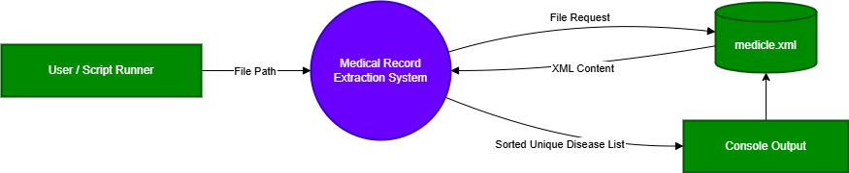

FLOWCHART